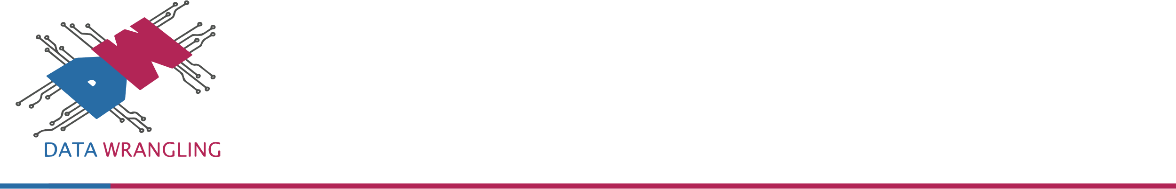Fhuad Balogun

Data Wrangling Limited,

9th Floor, Ibukun House,

14 Adetokunbo Ademola Street,

Victoria Island, Lagos.

October 28, 2020

Head Teacher

Leigh House School,

10 Akin Leigh Cres,

Lekki Phase I, Lagos.

Dear Sir,

Providing a solution to the problem of poor performances of pupils and reducing the rate of dropout and transfers is an often required and uneasy task across primary schools. Our team at Data Wrangling Limited have decided to work with some primary schools in Lagos to help build a machine learning model that could easily and quickly help predict pupils’ success in each and every subject offered and by so identify potentially at-risk pupils for early intervention.

Our team researched the growing concerns regarding pupil attrition in private primary schools in the country and we have decided to provide solutions using artificial intelligence to contribute to reducing attrition and improving pupil retention in this sector. By being able to identify potentially at-risk pupils very early in the session, we could help improve performance of pupils, which would lead to better pupil acquisition and retention and this would, in turn, increase revenue for the management.

 Some of our initial objectives are to:

1. Improve pupil performance and involvement.
2. Contribute to increasing pupil retention and by so improve graduation rate.
3. Increase revenue and profit for the school.

Our company is providing solution to a similar project with data from a foreign school and now, we want to provide a solution that fits the Nigerian system.

On behalf of myself and data wrangling research team, we earnestly express our gratitude in examining our request to build this solution for free for your school. If you have any questions or concern, you can send us an email to [info@datawrangling.io](mailto:info@datawrangling.io).

Best regards,

Fhuad Balogun

Data Scientist, Data Wrangling Limited

**About Data Wrangling**

Data Wrangling is a data-driven organization that aims to provide business transformation through the use and processing of data. From the gathering of information to final product delivery, Data Wrangling seeks to create value by automating the process of transforming large data sets into valuable information which is used in making better and more informed decisions.

We are an IT-Business Process Outsourcing service provider leveraging the power of artificial intelligence, data mining, and predictive analytics to unlock value and achieve business transformation for clients around the world through services that boost process and operational efficiencies. We help businesses achieve digital transformation by turning data into actionable insight and business intelligence.

Data Wrangling's deep industry-specific expertise helps us to tailor customized data science business process outsourcing services that match your business needs. We aim to enhance your growth and excellence while ensuring compliance with the industry, to follow quality and security standards.

**The Data Wrangling Advantage**

The adoption of latest technologies and processes, our skilled and certified workforce, implementation of data security measures, high-quality service delivery, and guaranteed transparency in all projects, enables us to provide customized solutions that meet your requirement.

**AREAS OF EXPERTISE**

We offer data science consulting services for large, medium-sized companies and startups to perform analytics research, design, build and deliver custom solutions that meet their unique need.

Our team of analytics experts help organizations to enable real-time actions, predict outcomes and present real-time reports to support business decisions.

**Big Data And Analytics**

* Store and manage your structured, and unstructured data no matter their location or format.
* Build big data architecture and manage your Data on cloud.
* Drive strategic initiatives and make data-driven decisions.

**Machine Learning and Predictive Analytics**

* Enable prediction & intelligent actions with Machine Learning.
* Develop Machine learning Models to build data-driven solutions.
* Machine learning consulting and development to build customized data science solutions.

**Business Intelligence Consulting**

* Consulting and Implementation of Data and Business Strategy for Business intelligence.
* Boost operation efficiency with interaction dashboards.

The most common way to present business intelligence is through data visualization, where users can understand the data without technical knowledge to dig, identify patterns and make informed decisions. Our business intelligence consultants leverage Power BI or Tableau as tools to create intuitive and stunning dashboards.

**Business Process Outsourcing**

* Scale resource capacity.
* Optimize productivity.
* Fulfil scarce skills.
* Reduce start-up time.

**OUR TEAM**

Data Wrangling is a team of enthusiastic and forward-thinking IT Consultants, Data Analysts, Data Engineers and Business Analysts. We create a respectful, rewarding, and productive work environment.

Our team of Data scientists are at the forefront of developing intelligent solutions on top of platforms like AWS, Azure or Google Cloud Platform and using technologies, tools such as Apache Spark, Jupyter Notebook, R and Dockers.

**SOME OF OUR CLIENTS**

   

